
A 10
SET NO : 1

Sreenidhi Institute of Science & Technology
(An Autonomous Institution)
Code No: 101CS01

B. TECH. I – Year II – Semester Examinations, July/Aug, 2011 (Regular)
DATA STRUCTURES AND C++ (Common to EEE, ECE, ECM)

Time: 3 Hours Max. Marks : 70

Note : No additional answer sheets will be provided.

Part-A (Objective Type)
Max.Marks:20

Answer all QUESTIONS.

1. Define the term Abstract Data Type (ADT).

2. In circular array representation of queue, if R points to last element in the queue and F points to a location before the first - element of queue. How many elements are there in the queue, if maximum size of array is N?

3. A linked data structure is constructed with nodes having only one link per node. There is exactly one node with link field NULL. Is this data structure necessarily a linked list or not? Justify your answer.

4. Which linear data structure is used to implement death first traversal of a graph?

5. Selection sort programme always performs n-1 passes. Is it possible to reduce the number of passes by including a test to end the programme when no more exchanges are required?

6. What is a complete Binary tree?

7. In what situation might you prefer linear search over Binary search?

8. For c++ class named Myclass, the member function whose prototype is
Myclass (const Myclass &);
is known as _____________________________________.

9. What is the difference between a friend function of a class and member function of a class?

10. a) An instance of class is known as _________________.

b) The variables within a class are known as _______________________.

Part – B
Max. Marks: 50

ANSWER ANY FIVE QUESTIONS.
EACH QUESTION CARRIES 10 MARKS.

1. a) Write a C programme to implement stack operations with arrays. [ 5 ]

b) What are the applications of stacks? [ 5 ]

2. a) Write a C programme that implements stack operations using a linked list. [ 5 ]

b) Write a C programme to find the position of element "X" in a linked list. [ 5 ]

3. Write a C programme to implement preorder traversal of a Binary tree without using recursion. [ 10 ]

4. Write C functions for [ 10 ]
i) Selection sort ii) Insertion sort

5. Demonstrate the construction of minimum spanning tree for the following graph. [ 10 ]

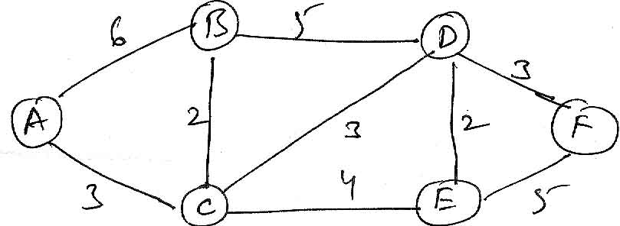

6. Write a C++ programme to create a complex number class with the following operations.
i) Addition ii) subtraction [ 10 ]
iii) multiplication iv) display complex number

7. a) Explain the order of sequence of constructors and destructors under inheritance of classes. [ 5 ]

b) Write a function template called max for returning the maximum element in an array. [ 5

8. Write short notes on [ 10 ]
a) sequential representation of Binary trees.

b) Representation of graphs.

c) Overloading functions

-- 00 -- 00 --

